Aims of puzzle:

The aim of the puzzle is to create a key card system for the door (using a button and a 3d printed insert to make a card swipe press the button) and allow for a code if applicable this will be done with the Arduino and the 16 x 2 display. This will then throw up an error code. Players will have to find a manual to figure out what the error code is (door mechanism not connected) and then find the instructions for wiring it up (connect the stepper motor to the correct free wire coming out of the Arduino, they then will need to connect the lock mechanism and close the keypad to open the door.

Puzzle Objective:

The objective of the puzzle is to get the players to use a code (or open a safe to get a key card with a code), once they have done this the keypad is going to display an error code. The players will then need to retrieve instructions for the lock that will be around the room. They then will need to either connect a pin on the Arduino to retract the bolt and unlock the door or short 2 pins to retract the bolt.

Planning the Project:

To ensure that the project is up to standard and that I have time to produce everything required, I created a Precedence diagram. This shows the best case and worse case timings and allows me to estimate the time required to make the project.

Research on the project:

Technology to run the project:

To create the best possible product, I had to research which technologies will best suit it. I looked through multiple options including the Raspberry Pi, Micro-Bit, and the Arduino.

I will be using the Arduino IDE software to code this project, in this I will be using the keypad and servo modules.

After researching the pros and cons of each system I decided to choose the Arduino, this is because:

* The Arduino is simple to use with a computer.
* The Arduino is cheaper than the Raspberry Pi
* There is lots of connectivity using the pins.
* The Arduino is designed for integrated systems such as this puzzle.
* The Arduino has low power consumption.

Ways to build the project:

There are many ways to make the enclosure for the project. I chose to use 3D printing, this is because when compared to other options such as resin printing or laser cutting, it provides the easiest way to perform rapid prototyping. This is important as the first design I make will not be the final, this is because as I test each iteration, I will be able to see how to improve it. For example, when I was sketching the product, I originally was going to use a hinge, after researching I found it to be cheaper and more durable to create a sliding mechanism. This is done by having 4 “slots” for pins with screws to slide in.

Player needs and experience:

When researching how to make the puzzle fun and challenging, while keeping it useable for people with any skill level I decided to ask friends and family about potential ideas, this is because they all have different technical skills and weaknesses. After discussion we decided to use a simple one cable connector. This is because while someone with technical skills will most likely be able to correctly wire up a motor, some may not. Using one connector ensures that all players can complete it successfully.

Puzzle Requirements:

* Puzzle must be easy to use and durable.
* Puzzle will take code off Seth’s puzzle before starting.
* Instructions must be readable by anyone including people with vision issues to ensure that the puzzle is accessible.
* Puzzle should show error code, before the user solves the issue.
* Puzzle should be customisable to the needs of the escape room company.
* Puzzle will run off 5 volts, to allow the user to “connect” parts with no risk of an electric shock.
* Puzzle should unlock the door when it is solved.
* Puzzle should be easily repairable with non-proprietary parts to ensure that the product is easy to fix and environmentally friendly.

Design of puzzle:

The puzzle needs to convincingly look like a lock, I looked around to see the most common designs of door locks and the parts I plan to use and created a simple mood board:

Sketches:

The first step of designing any product or puzzle is to do sketches, I decided to do digital sketches and to include how I plan to wire them.

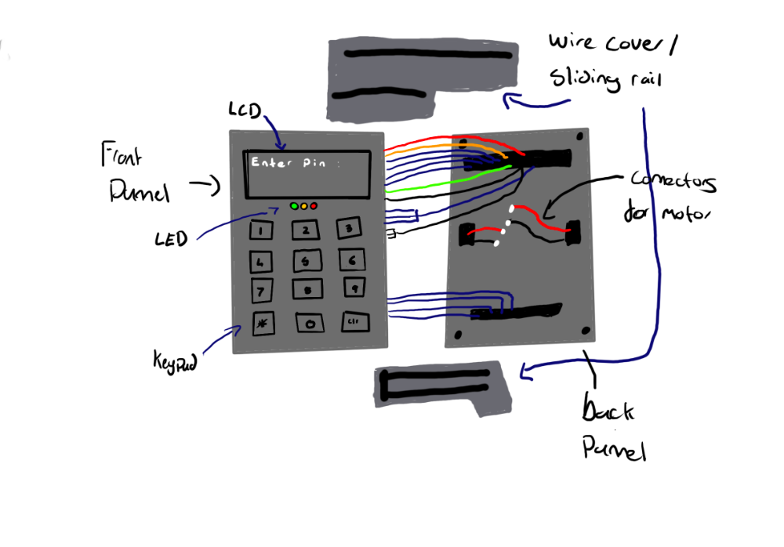

Modelling in photoshop:

While preparing my project in progress presentation I decided to model how the product works, this helps me see how I need to create the physical product, below are images of the puzzle in the locked, opened, and unlocked position:

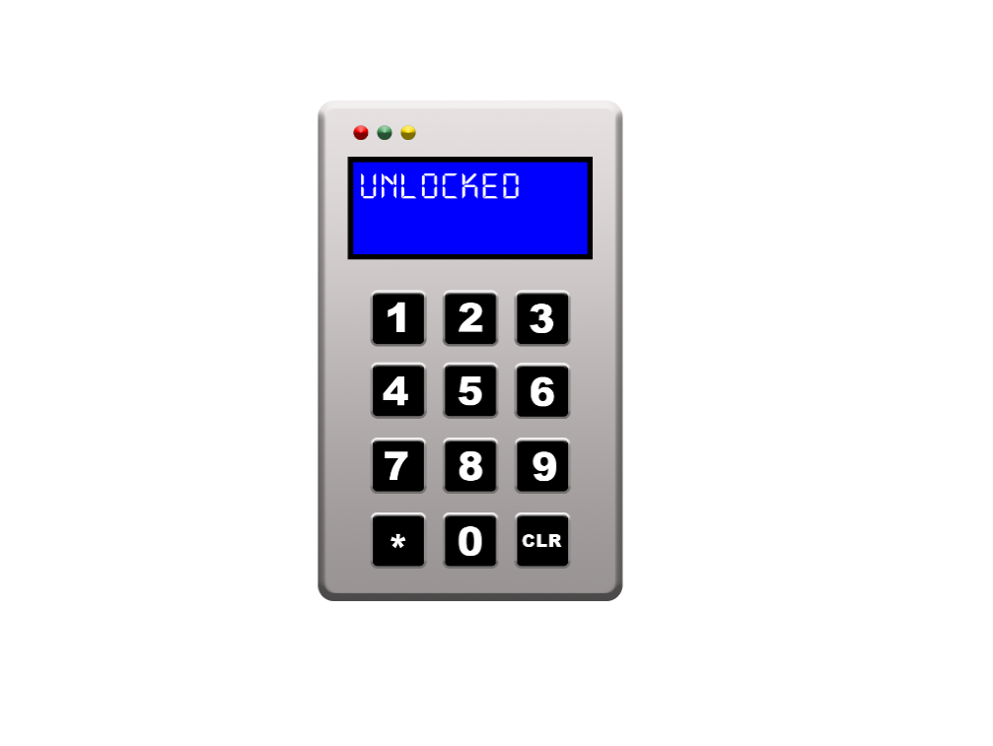

Feedback:

I consulted peers and family about the project and asked them to test out prototype hardware. All had similar feedback and thought the button system would be too fragile and easy to bypass. To counter this I decided to use pins to enter a “maintenance mode” and then to enter a manual override mode. This reduces the risk of structural failure and provides an easier solution to the problem. The codes will be hidden around the room in addition to the instructions.

The more technical among the peers giving feedback suggested that I used a servo instead of a standard motor, after trailing this I decided to use it. This is because it is faster and easier to configure for a client’s needs.

Testing

|  |  |  |  |
| --- | --- | --- | --- |
| Test Number | Test | Expected result | result |
| 1 | Enter wrong pin | Incorrect pin error | Incorrect pin error |
| 2 | Correct Pin | Err 27 message | Err 27 message |
| 3 | Maintenance mode | Enters correct mode | Enters correct mode |
| 4 | Wrong pin maintenance mode | Loops to start | Loops to start |
| 5 | Correct pin in maintenance mode | Servo on | Servo on |
| 6 | Don’t connect pin | Loop to start | Loop to start |
| 7 | Spam incorrect pins | Incorrect pin error | Incorrect pin error |
| 8 | Connect wrong pins | No error no unlocks | No error no unlocks |

Weekly Log

Week 1 – Downloaded the Arduino IDE and began to try make prototype code.

Week 2 – Bought an Arduino mega and keypad.

Week 3 – wired up and created prototype software.

Week 4 - Finalised code and began testing.

Week 5 – Gathered feedback from peers and family.

Week 6 – Created Poster